Overview:

|  |  |  |  |  |
| --- | --- | --- | --- | --- |
|  |  | N=3 | N=5 | N=7 |
| Nonexcluable public good min delay | Two-peak  Normal1(0.1,0.1), Normal2(0.9,0.1) | 2.22  2.22(upbound) | 3.562  3.581(upbound) |  |
| Nonexcluable public good max welfare: | Two-peak  Normal1(0.1,0.1), Normal2(0.9,0.1) | 0.304  0.306(upbound) | 0.590  0.590(upnound) |  |
| Excluable public good min delay: | Two-peak  Normal1(0.1,0.1), Normal2(0.9,0.1) |  | 1.78 | 1.69 |
| U-exponential  Exponential1(15)  1-Exponential2(15) | 1.75 |  |  |
| beta_a 0.1  beta_b 0.1  approximate by  kumaraswamy_a  0.1  kumaraswamy_b  0.354 | 1.78 |  |  |
| beta_a 0.3  beta_b 0.2  approximate by  kumaraswamy_a  0.3  kumaraswamy_b  0.40 | 1.29 |  |  |
| Excluable public good max welfare: | Two-peak  Normal1(0.2,0.05), Normal2(0.4,0.05) | 0.278 |  |  |
| Two-peak  Normal1(0.2,0.1), Normal2(0.6,0.1) | 0.185 |  |  |
| Two-peak  Normal1(0.3,0.1), Normal2(0.7,0.1) | 0.377 |  |  |

Nonexcluable public good min delay：

Two-peak:

Normal1(0.1,0.1), Normal2(0.9,0.1)

N=3:

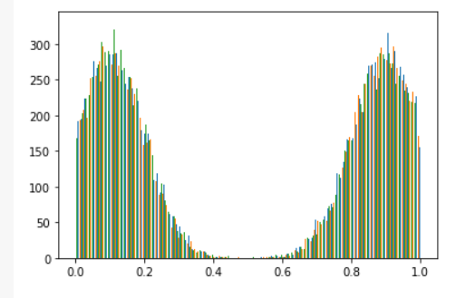

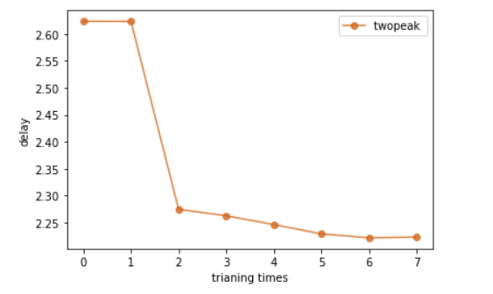

NN: 2.2228

CS: 2.6236

DP: 2.2342

DP: 2.2242771685123444

Dp optimal result: 2.2242771685123444

Normal1(0.1,0.1), Normal2(0.9,0.1)

N=5:

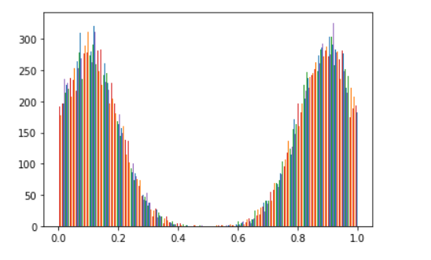

NN: 3.562333333333333

CS: 4.6273333333333335

DP: 3.574

DP: 3.581627309322357

Dp optimal result: 3.581627309322357

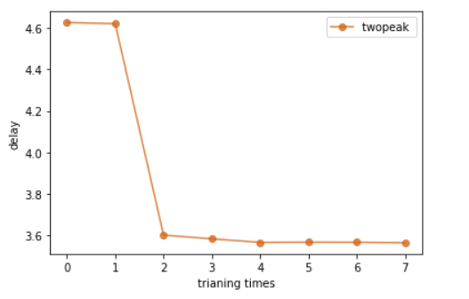

Nonexcluable public good max welfare:

N=3:

Normal1(0.1,0.1), Normal2(0.9,0.1)

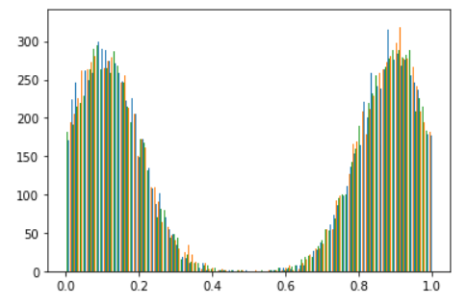

NN 4 : 0.30429031834602355

CS 4 : 0.20003899814685186

DP 4 : 0.3061903769354026

DP: 0.3150000375509262

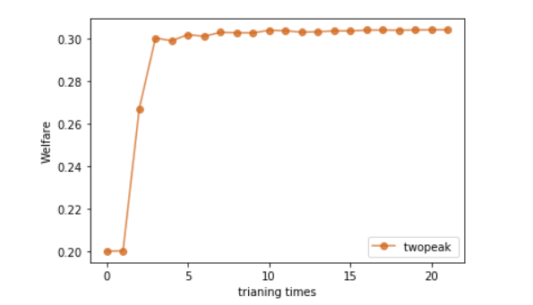

N=5:

Normal1(0.1,0.1), Normal2(0.9,0.1)

NN : 0.5908675303220748

CS : 0.19859909861485164

DP : 0.5907956558366616

DP : 0.5999038791656495

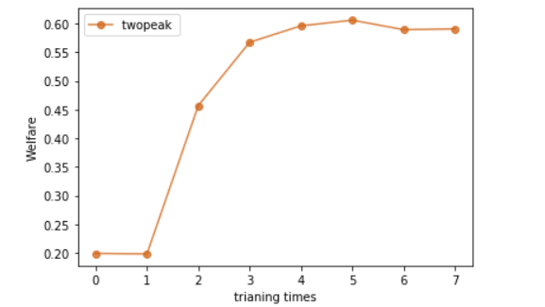

Excluable public good min delay:

Normal1(0.1,0.1), Normal2(0.9,0.1)

N=5:

NN 5 : tensor(1.7801)

CS 5 : 2.5331

DP 5 : 1.8676

heuristic 5 : 1.8589

DP: 1.8651759624481201

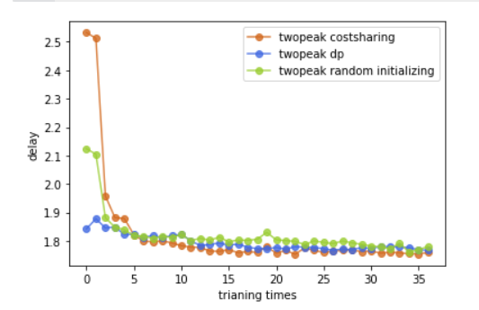

penalty: 0.0

NN 5 : tensor(1.7801)

CS 5 : 2.5331

DP 5 : 1.8676

heuristic 5 : 1.8589

DP: 1.8651759624481201

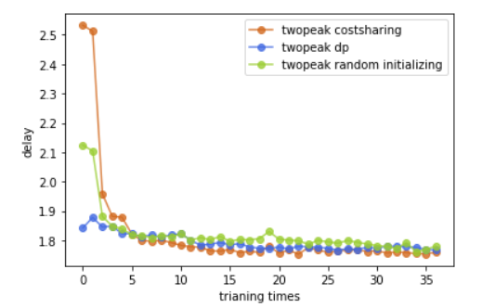

Normal1(0.1,0.1), Normal2(0.9,0.1)

N=7:

NN 5 : tensor(1.6932)

CS 5 : 2.9445

DP 5 : 1.7524166666666667

heuristic 5 : 1.7480833333333334

DP: 1.7726764678955078

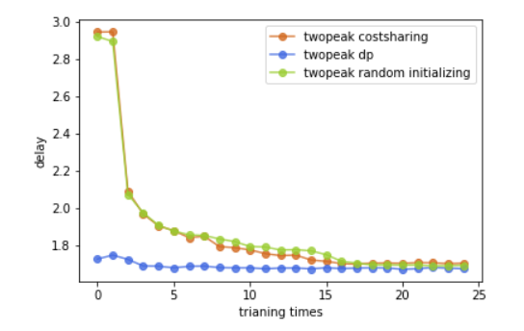

U-exponential(two)

Exponential 15

Exponential 15

n = 3

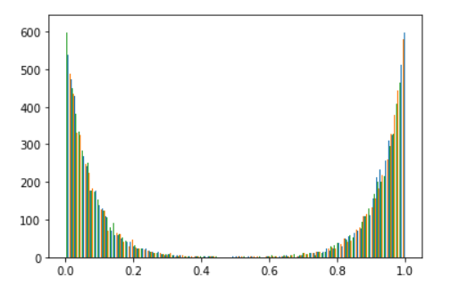

penalty: 0.0

NN 4 : tensor(1.7534)

CS 4 : 1.8772

DP 4 : 1.7529

heuristic 4 : 2.0059

DP: 1.75

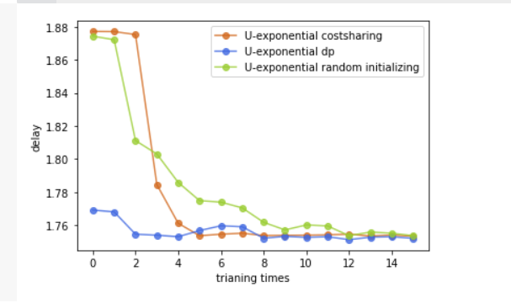

Beta approximation

beta_a 0.1 beta_b 0.1

kumaraswamy_a 0.1 kumaraswamy_b 0.3540388371733616

n=3

NN 7 : tensor(1.7813)

CS 7 : 1.7839333333333334

DP 7 : 1.7580666666666667

heuristic 7 : 1.7560666666666667

DP: 2.2055420875549316

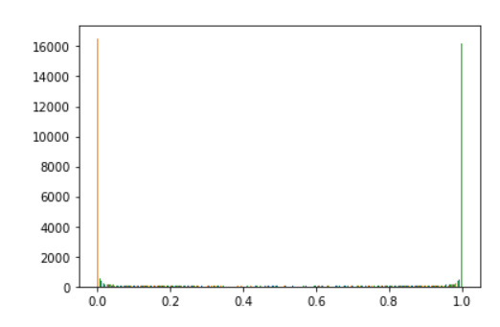

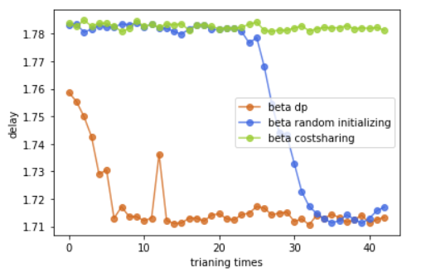

beta_a 0.3 beta_b 0.2

kumaraswamy_a 0.3 kumaraswamy_b 0.40058530825361593

n=3

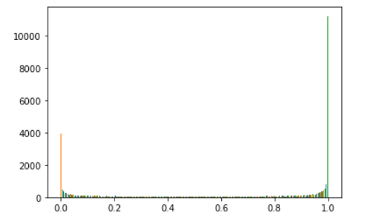

penalty: 0.0025746822357177734

NN 6 : tensor(1.2961)

CS 6 : 1.3570666666666666

DP 6 : 1.3002666666666667

heuristic 6 : 1.5662666666666667

DP: 1.7036516666412354

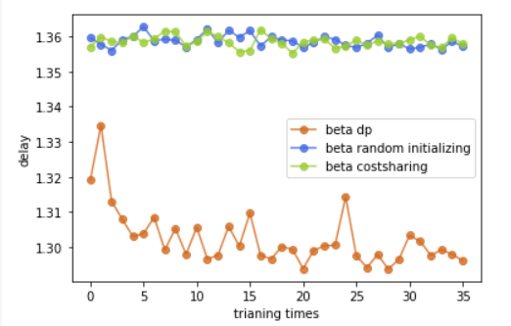

Excluable public good max welfare:

Normal1(0.2,0.05), Normal2(0.4,0.05)

N=3:

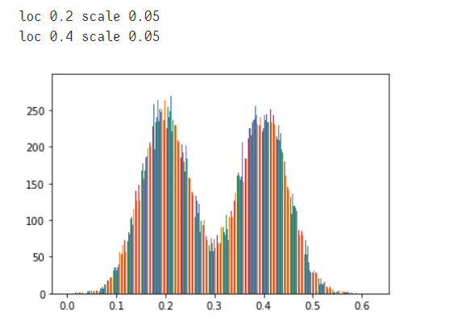

penalty: 0.0

NN 2 : tensor(0.2783)

CS 2 : 0.2773620503604412

DP 2 : 0.2682859631717205

heuristic 2 : 0.2662026878476143

DP: 0.2631515860557556

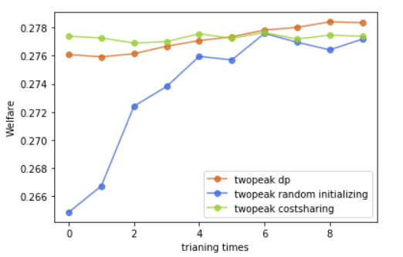

Normal1(0.2,0.1), Normal2(0.6,0.1)

N=3:

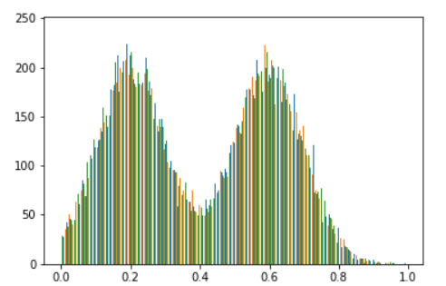

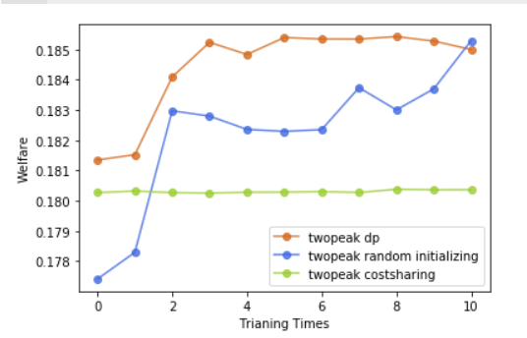

penalty: 0.0

NN 3 : tensor(0.1850)

CS 3 : 0.18026652864615123

DP 3 : 0.17906427003542583

heuristic 3 : 0.1622357147693634

DP: 0.18493148684501648

Other try:

penalty: 0.0

NN 2 : tensor(0.1876)

CS 2 : 0.18337190340161325

DP 2 : 0.18032471189498903

heuristic 2 : 0.18636823990941048

DP: 0.18225233256816864

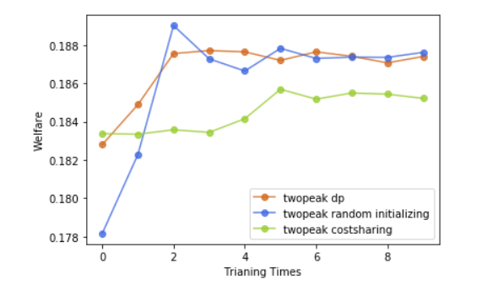

Normal1(0.3,0.1), Normal2(0.7,0.1)

N=3:

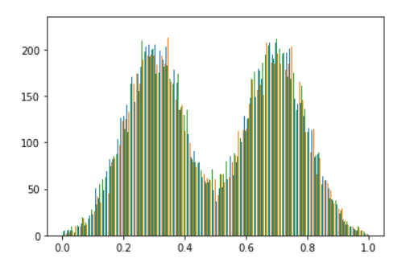

penalty: 0.0

NN 3 : tensor(0.3777)

CS 3 : 0.37547979027430217

DP 3 : 0.3635297166983287

heuristic 3 : 0.37021485330263776

DP: 0.36118757724761963

People Choice:

Normal1(0.1,0.1), Normal2(0.9,0.1)

N=5:

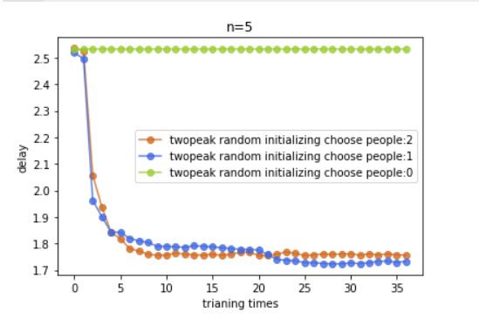

Other try:

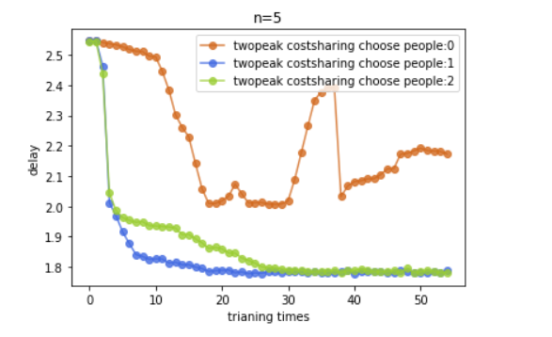

## Redistribution:

n=3:

min value:1.9951419

max vaule:2.6215868

mean: 2.071576

Probability density graph:

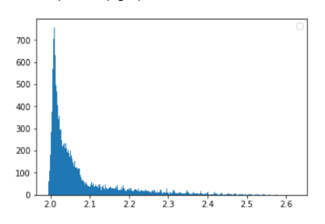

n=5:

min value:3.9614959

max vaule:4.966861

mean: 4.0610538

Probability density graph:

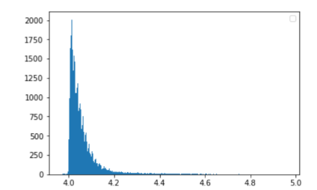

n=10:

min value:8.847169

max vaule:10.850268

mean: 9.018242

Probability density graph:

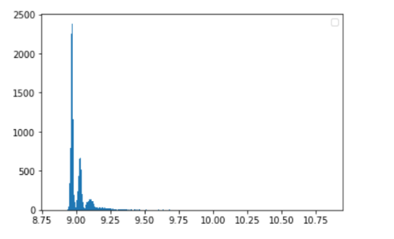

--

Other try:

N=3

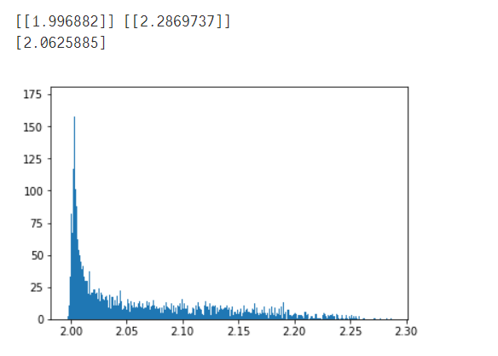

N=4

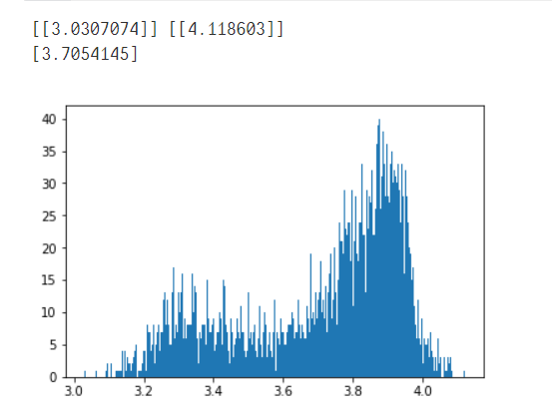

N=5

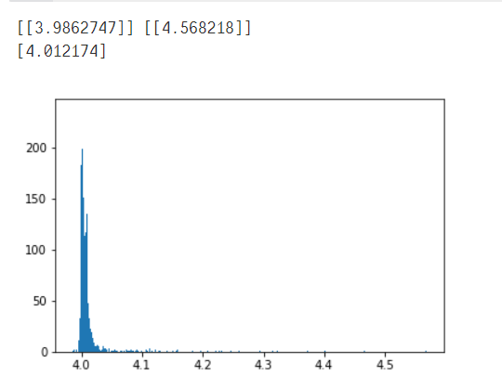

N=6

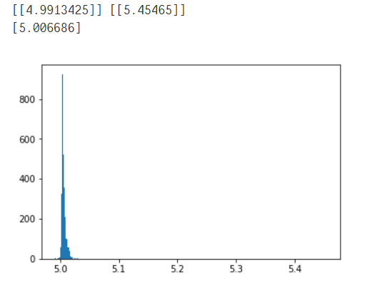

N=7

